Launch Linux EC2 instances in two regions using a single Terraform file.

**First, we need to Set Up the Terraform Configuration File:**

* We need to create main.tf file.

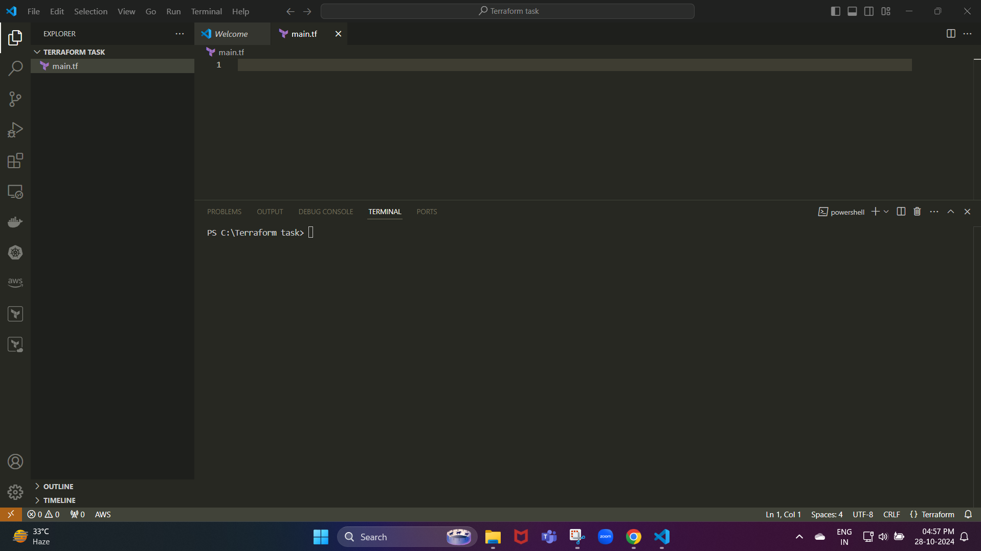

Next, we need to create a configuration file in that created file.

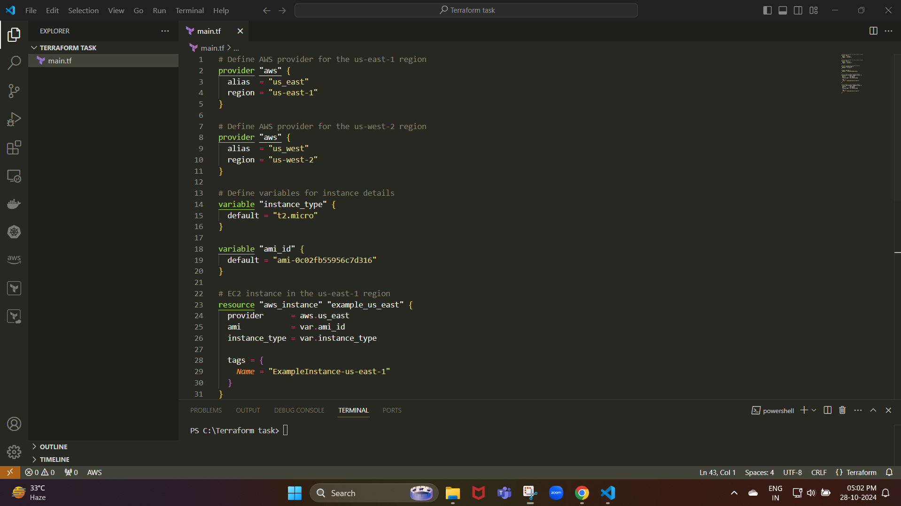

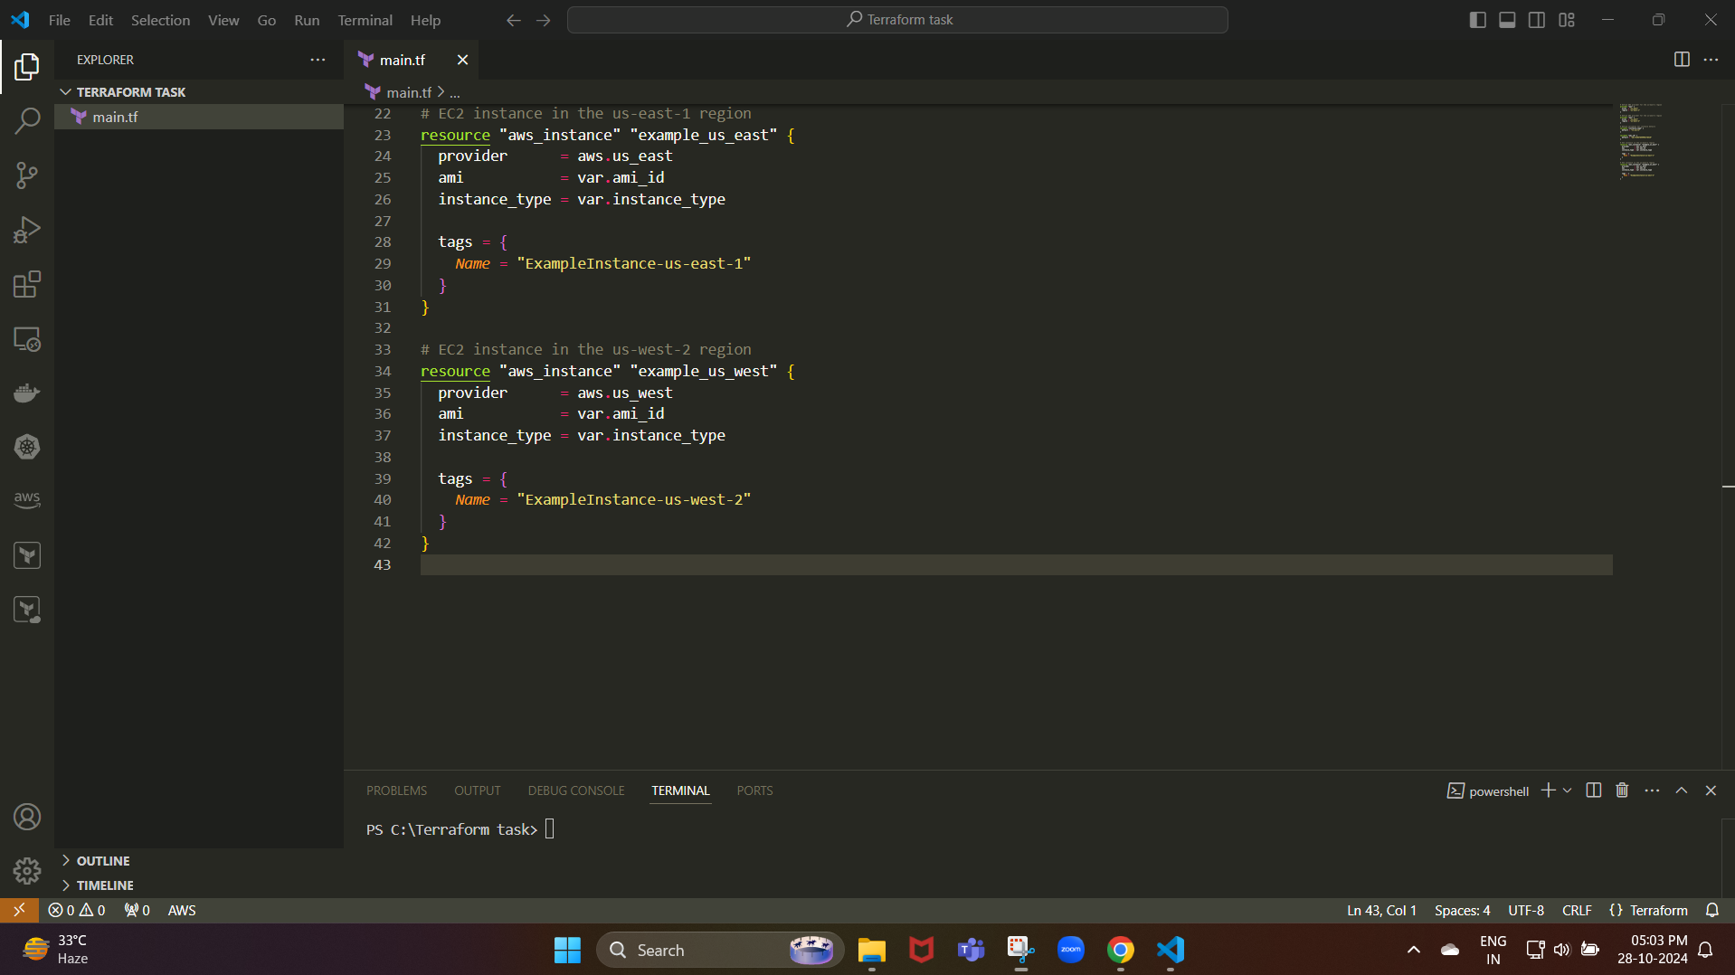

The **main.tf** file in Terraform is typically where you define your configuration for deploying infrastructure.

This includes providers, resources, variables, and other settings that specify the infrastructure you want to create.

In Terraform, variables allow you to define reusable and flexible values for your configuration,

Making it easy to customize settings (like instance types and AMI IDs) across different environments without altering the code itself.

Next, we need to initialize the terraform project:

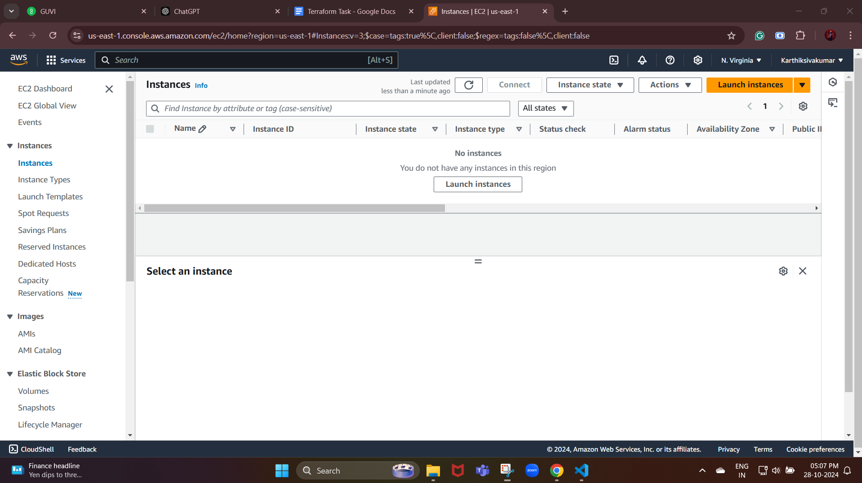

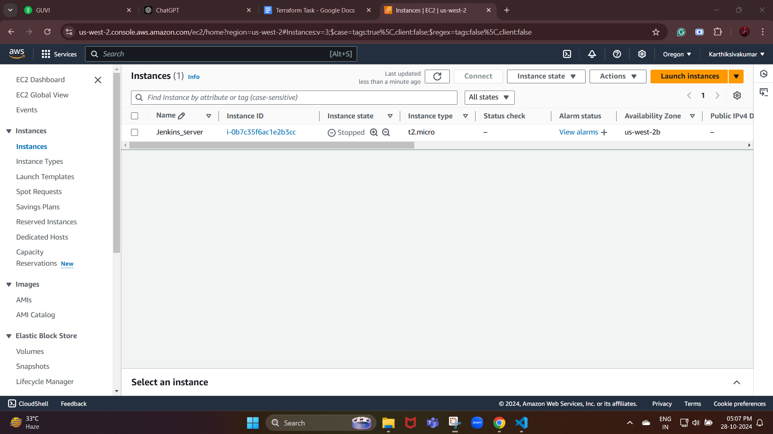

These are the instances we had before we ran the Terraform project.

* Run terraform init to initialize the project and download necessary provider plugins

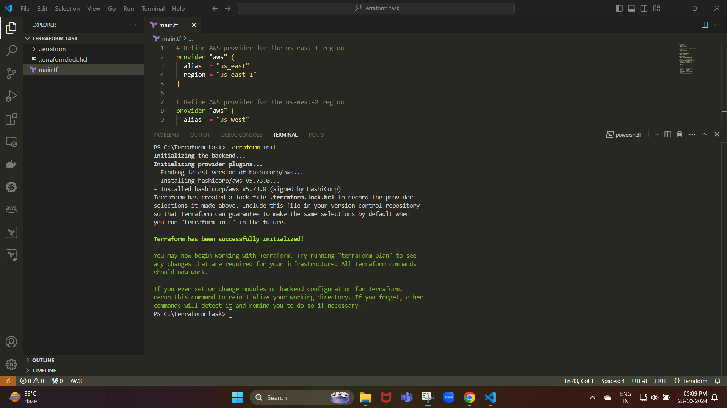

Now, we initialize the terraform project.

This sets up Terraform to work with AWS and prepares your project for deployment.

Next, we need to review the terraform plan:

* Run terraform plan to preview what Terraform will create. This command helps ensure your configuration is correct before applying any changes

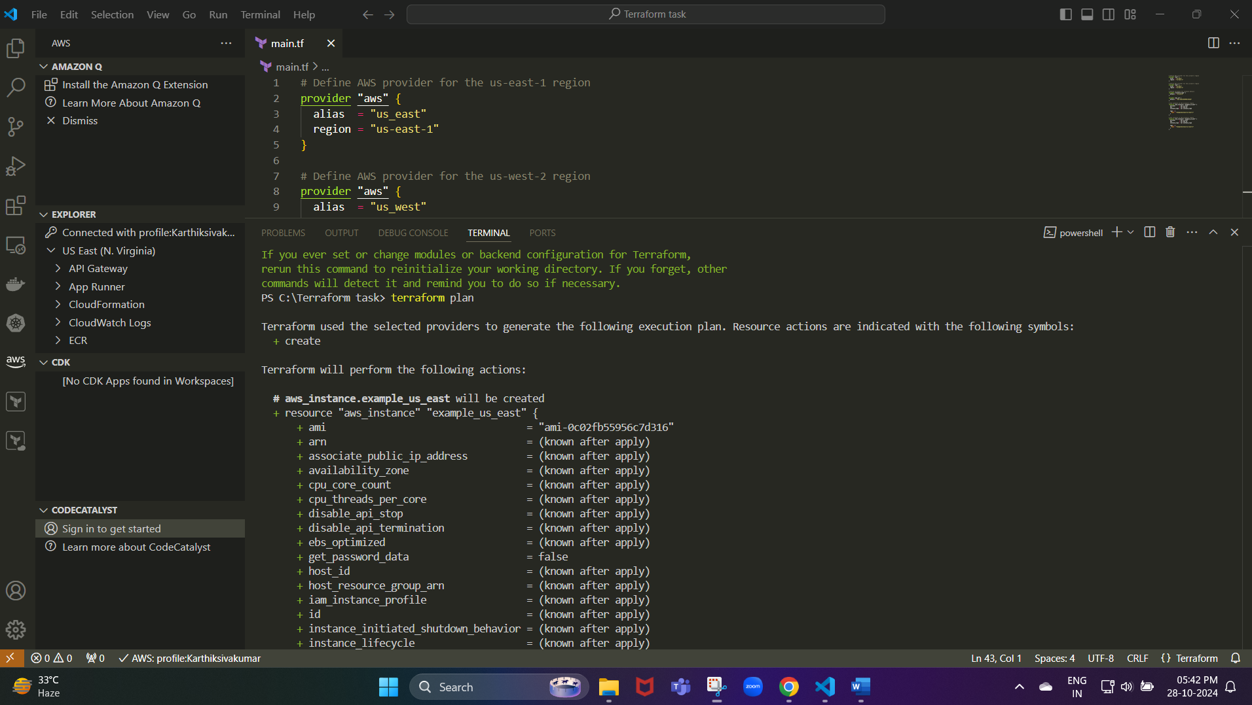

Next, we need to apply the configuration:

We need to type yes to approve

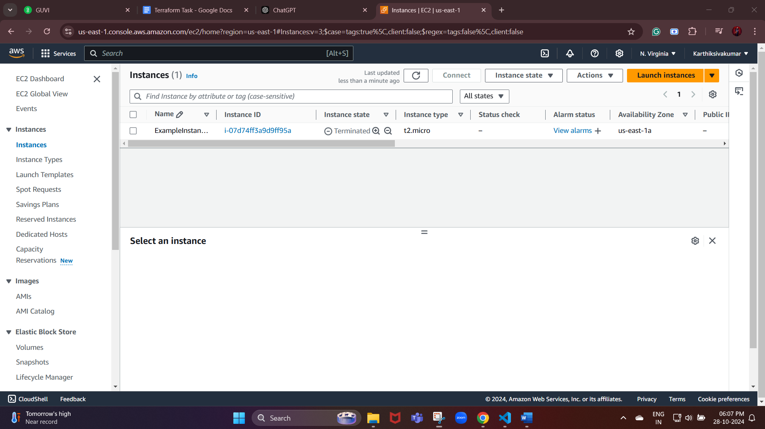

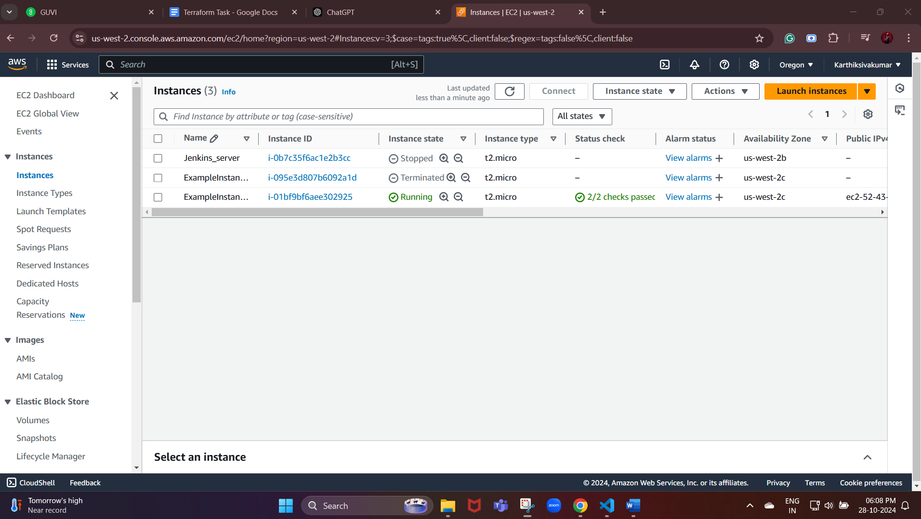

Once finished testing, you can delete the instances to avoid incurring charges

Run terraform destroy to remove all resources created by the configuration